**Project Planning Phase**

Project Planning Template (Product Backlog, Sprint Planning, Stories, Story points)

|  |  |
| --- | --- |
| **Date** | **18 Nov 2022** |
| **Team ID** | **PNT2022TMID37388** |
| **Project Name** | **Visualizing And Predicting Heart Diseases with**  **An Interactive Dash Board** |
| **Maximum Marks** | **8 Marks** |

Product Backlog, Sprint Schedule, and Estimation (4 Marks)

|  |  |  |  |  |  |  |
| --- | --- | --- | --- | --- | --- | --- |
| **Sprint** | **Functional Requirement (Epic)** | **User Story Number** | **User Story / Task** | **Story points** | **Priority** | **Team Members** |
| Sprint1 | Data Preprocessing and Exploratory Data  Analysis(EDA) | USN-1 | Data cleaning is implemented to check whether, there are any null values or any outliers are found | 10 | Medium | Yokesh J  Kishore b |
|  |  | USN-2 | Testing and Training the data model is implemented using Jupyter notebook | 10 | High | Esakki muthu.M  Kameshwar R |
| Sprint2 | Working with dataset | USN-3 | Working with the Dataset. Understand Dataset Load the Dataset  Explore the Data  Visualize the Data. | 20 | Medium | Kameshwar R  Kishore B |
| Sprint3 | Data Visualization | USN-4 | we plan to create various graphs and charts to highlight the insights and  visualizations with the given attributes | 20 | High | Esakki muthu.M  Yokesh J |
| Sprint4 | Dashboard | USN-5 | Dashboard Showing Different Types Of Visuals | 15 | High | Kameshwar R  Yokesh J |

**Velocity:**

Imagine we have a 10-day sprint duration, and the velocity of the team is 20 (points per sprint). Let’s calculate the team’s average velocity (AV) per iteration unit (story points per day)

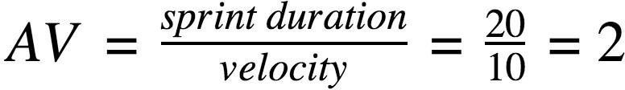

**BURNDOWN CHART**



**BurntDown Chart**

**80**

**70**

**66.66666667**

**53.33333333**

**42**

**40**

**25**

**26.66666667**

**13**

**13.33333333**

**8**

DAY 0

DAY 1

DAY 2

DAY 3

DAY 4

DAY 5

**0**

DAY 6

remaining effort ideal effort